You are the Master of the game:
Ask a question to team A. Read it twice (some written clues can be given).
For some questions you will have to give attached files.
Control the timing (max 30 s).
Check the answer and the pronunciation (in italic type below).
Once the right answer is given, the team can roll the dice and move forward on the snakes and ladders board.
Repeat the process with team B and the next question etc.

Question 1 Find the derivatives of the following polynomials:
a) 3x-7 b) x²-7x+4 c) 3x³- 2x² + x +1 _______________________________________________________________________________________
Answer Question 1 a) 3 b) 2x-7 c) 9x²-4x+1

Question 2 Find the derivatives of the following polynomials:
a) b) 3x⁵ +x (pronunciation of : [pai])
_______________________________________________________________________________________
Answer Question 2 a) b) 15x⁴+

Question 3 Find the derivative of the following rational function: _______________________________________________________________________________________
Answers Question 3 (f prime of x equals or f dash x equals….)

Question 4 Find the derivative of the following rational function:
_______________________________________________________________________________________
Answer Question 4 (f prime of x equals or f dash x equals…. )

Question 5 Given that : find . (“dy by dx” or “the derivative of y with respect to x”)
_______________________________________________________________________________________
Answer Question 5 (“the derivative of y with respect to x” or “dy by dx” equals 54x to the power of 8 or 54x to 8)

Question 6 Given that : find . (“dy by dx” or “the derivative of y with respect to x”)
_______________________________________________________________________________________
Answer Question 6 (“the derivative of y with respect to x” or “dy by dx” equals 1500x to the power of 499 +1500 to the power of 99) can be factorized into this form: 1500x⁹⁹(x⁴⁰⁰ +1).

Question 7 Find . (the derivative of 2 times the square root of x with respect to x)
_______________________________________________________________________________________
Answer Question 7

Question 8 Find the equation of the tangent to the curve with equation at the point where .
_______________________________________________________________________________________
Answer Question 8 The equation is

Question 9 Find the gradient (or the slope) of the tangent to the curve with equation at .
_______________________________________________________________________________________
Answer Question 9 The derivative is so the gradient is .

Question 10 GIVE THE ATTACHED FILE “QUESTION 10” TO THE TEAMS
Given this curve, find f ’(0) and f ’(1).

HELP : Reminder of the lesson:

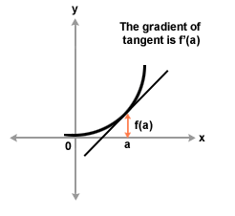

_______________________________________________________________________________________
Answer Question 10

Question 11 GIVE THE ATTACHED FILE “QUESTION 11” TO THE TEAMS
Given the curve opposite find the sign of the derivative.

HELP : Reminder of the lesson:
If f ′(x) > 0 at each point in an interval I, then the function is increasing on I.
If f ′(x) < 0 at each point in an interval I, then the function is decreasing on I.

_______________________________________________________________________________________
Answer Question 11 The derivative is positive in the intervals ]-∞ ; 0[ and ]2 ; +∞[ and negative in the interval ]0 ; 2[
You could draw a table :
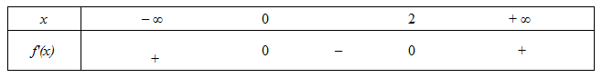
Question 12 GIVE THE ATTACHED FILE “QUESTION 12” TO THE TEAMS
Given the curve opposite find f ’(2) and f ’(-2).
HELP : Reminder of the lesson:

_______________________________________________________________________________________
Answer Question 12

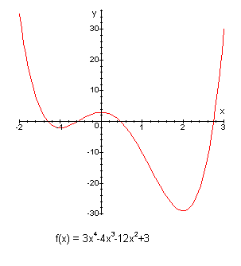
Question 13 GIVE THE ATTACHED FILE “QUESTION 13” TO THE TEAMS
Given the curve opposite find the sign of the derivative.

HELP : Reminder of the lesson:
If f ′(x) > 0 at each point in an interval I, then the function is increasing on I.
If f ′(x) < 0 at each point in an interval I, then the function is decreasing on I.

_______________________________________________________________________________________
Answer Question 13 The derivative is positive in the intervals ]-1 ; 0[ and ]2 ; +∞[ and negative in the intervals ]-∞ ; -1[ ]0 ; 2[. You can draw a table :
Question 14 GIVE THE ATTACHED FILE “QUESTION 14” TO THE TEAMS
Given the sign of the derivative, describe the variations of function f.
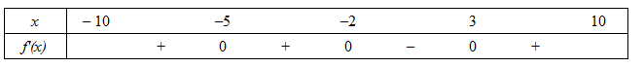
_______________________________________________________________________________________
Answer Question 14 Function f is decreasing on the interval [-2 ; 3] and increasing on the intervals [-10 ;-2] and [3 ;10 ]

Question 15 GIVE THE ATTACHED FILE “QUESTION 15” TO THE TEAMS
Given the sign of the derivative, describe the variations of function f.
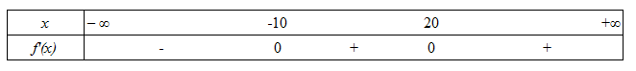
_______________________________________________________________________________________
Answer Question 15 Function f is decreasing on the intervals ]-∞ ; -10] and ]20 ; +∞[ ; increasing on the intervals [-10 ;20]

Question 16 Differentiate
Answer Question 16 (“the derivative of y with respect to x” or “dy by dx” equals…)

Question 17 Given that
Find and then the gradient (or the slope) of the curve at the point (3 ; -7)
Answer Question 17
- (“the derivative of y with respect to x” or “dy by dx” equals…).
- At (3 ; -7) x = 3. Substituting x = 3 in the expression gives :

